Last Updated: 10/26/2022
This Quick Reference Guide (QRG) outlines the Supervisor’s process of accessing Compensation Statements that detail merit award information for their direct reports.

Accessing Individual Compensation Statements
Via the OneCampus portal (one.purdue.edu), select Employee Launchpad

Log in using Purdue Career Account ID and BoilerKey.
OPTION 1:  - Search for employee’s profile by entering name in Search field.  - Click name to open profile. | 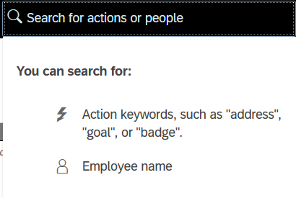
Once the profile is displayed, click Compensation Statement.
- Click the 20XX Merit Planning hyperlink to view the current year’s statement in your browser.  - Choose theicon to download a PDF version of the statement. | 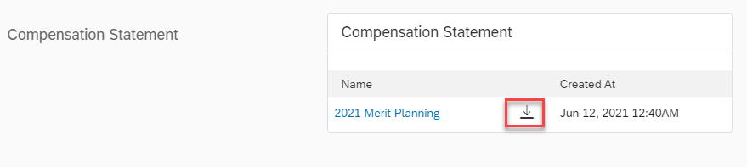
- The statement will contain the Performance Rating for staff employees.  - For hourly paid employees, it will show the current hourly base pay and annual base pay. For monthly paid employees, it will show the current annual base pay.  - The Merit % Increase is the Grand Total % and includes the Merit, Equity and Extra Merit increase.  - If an employee was promoted, the promotion $ increase and total % increase will be included.  - For hourly paid employees, it will show the new hourly base pay and annual base pay. For monthly paid employees, it will show the new annual base pay.  - If an employee receives a lump sum, it will be reflected on the statement as such. | 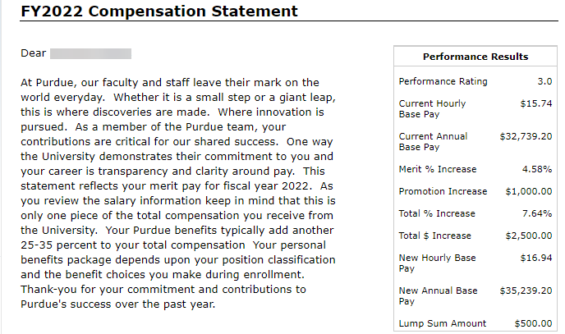
OPTION 2:
Go to My Team from the SuccessFactors Home Page.

Choose the Employee you would like to view. Select Compensation Statement. | 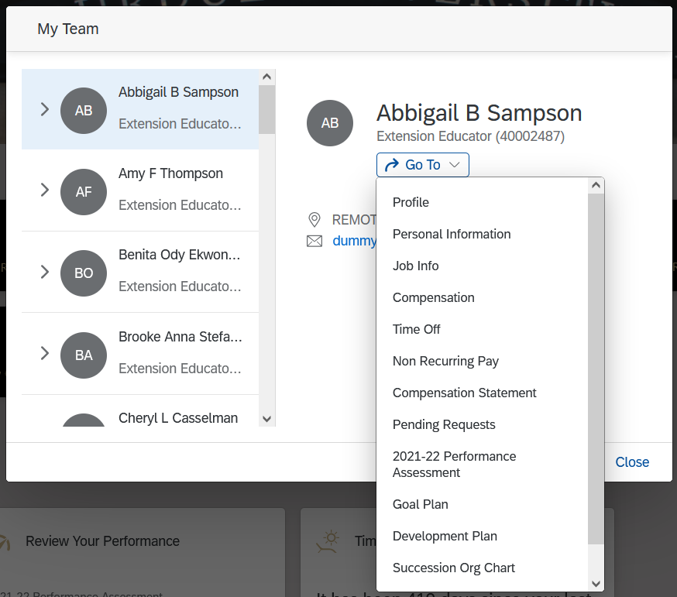
- Click the 20XX Merit Planning hyperlink to view the current year’s statement in your browser.
- Choose theicon to download a PDF version of the statement.
- The statement will contain the Performance Rating for staff employees.
- For hourly paid employees, it will show the current hourly base pay and annual base pay. For monthly paid employees, it will show the current annual base pay.
- The Merit % Increase is the Grand Total % and includes the Merit, Equity and Extra Merit increase.
- If an employee was promoted, the promotion $ increase and total % increase will be included.
- For hourly paid employees, it will show the new hourly base pay and annual base pay. For monthly paid employees, it will show the new annual base pay.
- If an employee receives a lump sum, it will be reflected on the statement as such.
Note: Even if an employee has not received a merit increase, they will receive a Compensation Statement indicating no change in their salary. If you have any questions about the Compensation Statements, please contact your Compensation Analyst or compensation@purdue.edu.

